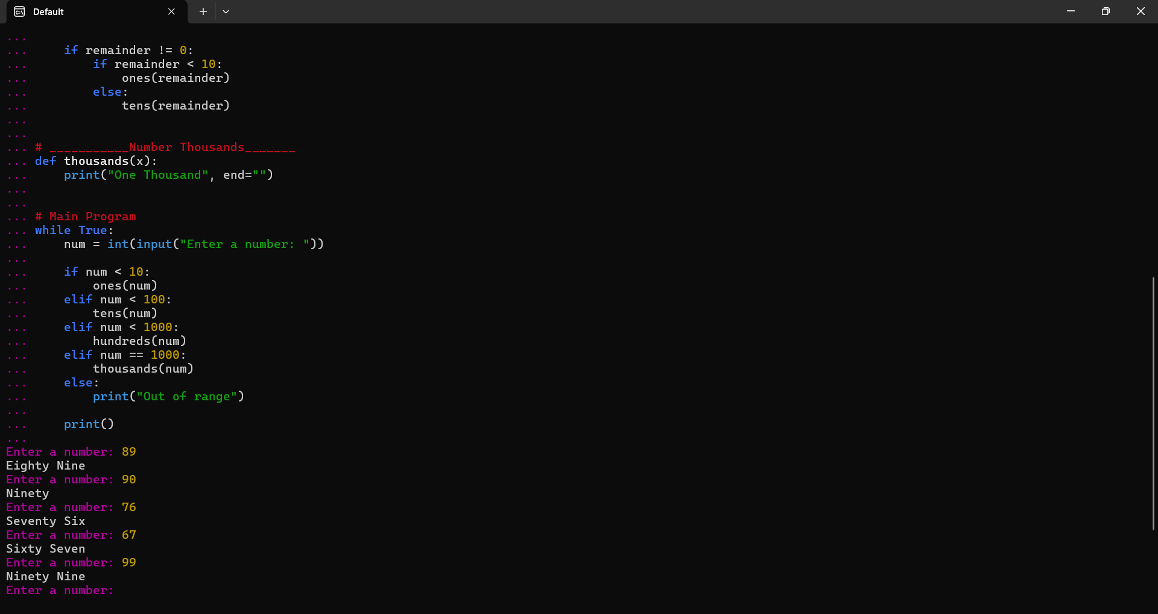
Bautista, Leigh Denisse C. BSIT-1E

